Analyzing the Titanic Passengers Dataset Using Advanced MySQL Queries
To convert Excel file into CSV and create a database using USE keyword named as titanic and go-to table import csv file from desktop
Task 1:
Write a query to find the name and age of the oldest passenger who survived.
Query:
create view old_passenger as
select first_name,last_name,age from titanic where age>40 and survived=1;
select * from old_passenger;
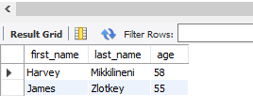

Task 2:
Create a view to display passenger survival status, class, age, and fare.
Query:
create view passenger as
select survived,class,age,fare from titanic;
select * from passenger;
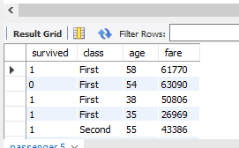

TASK 3:
Create a stored procedure to retrieve passengers based on a given age range.
Query:
DELIMITER //
create procedure passenger_agerange1(in age1 int,in age2 int)
Begin
select * from titanic where age between age1 and age2;
end//
DELIMITER ;
call passenger_agerange1(20,40);

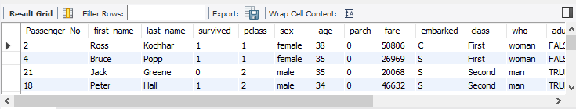

TASK 4
Write a query to categorize passengers based on the fare they paid: 'Low', 'Medium', or
'High'.
Query:
Select first_name,last_name,fare,
case
when fare<25000 then "Low"
when fare<40000 then "Medium"
else "High"
end as fareclass
from titanic;
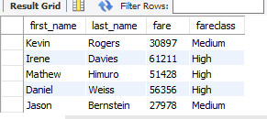
Task 5:
Show each passenger's fare and the fare of the next passenger.
Query:
Select first_name,last_name,class,fare,
lead(fare) over(
partition by class order by fare desc)
as next_fare from titanic;
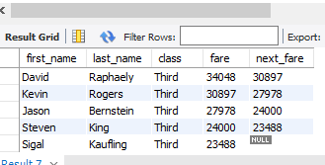

TASK 6:
Show the age of each passenger and the age of the previous passenger.
Query:
Select age,
lag(age) over(
partition by age order by age desc)
as prev_age from titanic;
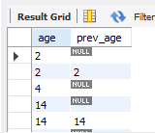

TASK 7:
Write a query to rank passengers based on their fare, displaying rank for each passenger.
Query:
select first_name,last_name,class,fare,
rank() over(
partition by class order by fare desc) as fare_rank from titanic;

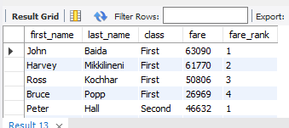

Task 8
Write a query to rank passengers based on their fare, ensuring no gaps in rank
Query:
select first_name,last_name,class,fare,
dense_rank() over(
partition by class order by fare desc) as fare_rankgap from titanic;
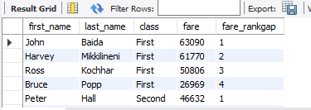

Task 9:
Assign row numbers to passengers based on the order of their fares.
Query:
select first_name,last_name,class,fare,
row_number() over( partition by class order by fare) as rn from titanic;
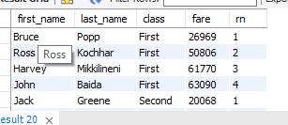

Task 10:
Use a CTE to calculate the average fare and find passengers who paid more than the
average.
Query:
with average_fare as
(select class,avg(fare)as avg_fare from titanic group by class having avg_fare>2)
select * from average_fare;
